1. GUI Program to display the current mouse coordinates on the window.

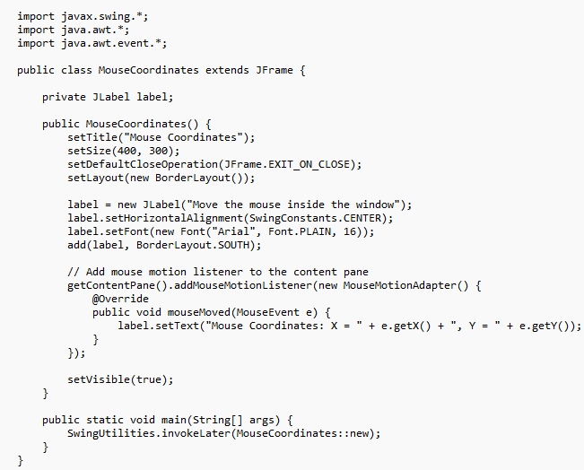

1. GUI Program to implement a simple Timer (using background events). Include a Start and Stop button to control the timer.

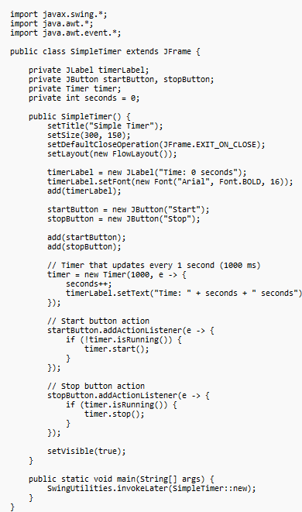

1. Create a GUI with a JComboBox containing image names. On selection, display the corresponding image using a JLabel and ItemListener.

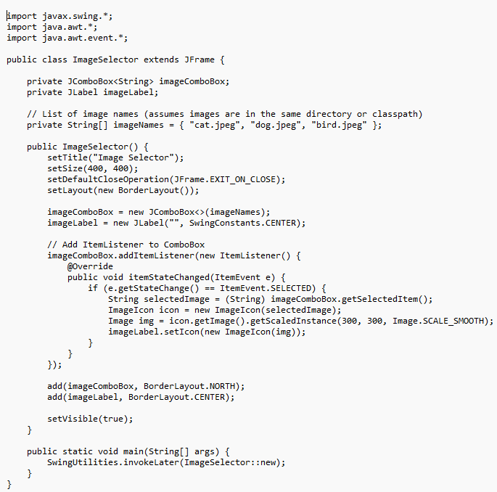

1. GUI with a JTextArea and a label. As the user types, show the character count and word count in real-time using a KeyListener.

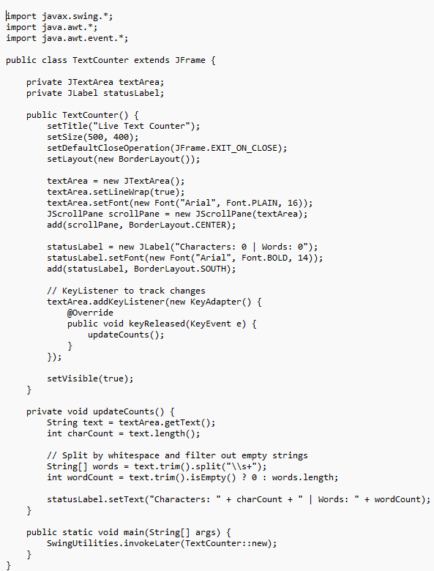

1. Write Java GUI Program using Swing to change background on selecting color.

